A Simple Bible Study Method
When I first began to read and study the Bible, I felt so overwhelmed and ill-equipped. I had no idea where to start, what to read, or how to study the Bible. Thankfully, through an incredible home church, I was able to grow in my faith and learn how to begin.
There isn’t a perfect/exact way to study the Bible. There are quite a few different methods. Some are way more sophisticated (Inductive Study), and others are artsier (looking at you Bible Journaling).
Each has a reason and purpose behind it, yet for me, I needed to start with something simple yet effective. That’s where the S.O.A.P. method comes into play.
S-Scripture
O-Observation
A-Application
P-Prayer

What Is The SOAP Bible Study Method?
The SOAP Bible Study Method is an easy way to study your Bible, breaking down scriptures into manageable pieces, and identifying what is being said and how it can apply to your life.

All you need is your Bible, a reading plan, a pen, and some paper. You could even download the PDF, which includes free printable SOAP outlines to make your study easier.
Using this method, as you read, you would identify a verse or verses that were either difficult to understand or stood out to you for one reason or another.
You would jot down the scripture under the scripture heading, next write what you observed from the text (under observation), then how you could apply what you just learned, and finally, you’d write a prayer that referenced the verse, or what you just learned, or asking God to help you understand. Don’t worry, I break it down even more, below.
This method helped me tremendously. It was simple enough to understand and remember for years to come. It helped me dig deeper and opened up the door for many other different methods of study. As a baby Christian/new believer, I wasn’t ready for the inductive study method or other complicated versions.
In school, we don’t jump into calculus before taking basic math and algebra; why would this be any different?

STEP-BY-STEP Break Down - SOAP
Here is an example of how I would go through the S.O.A.P method while reading Mark 1. Let’s go through it together!

Step 1: Develop a Plan
You don’t have to read the Bible from beginning to end, or in any particular order. Although you can start anywhere, you’re more likely to follow through with a plan rather than selecting passages as you go. So, instead of opening the Bible and randomly picking a passage, find a plan that works for you and follow-through, one paragraph or chapter at a time.

Recommended Bible Reading Plan:
- Start in the Gospels (the books of Matthew, Mark, Luke, or John). In these four books, you will learn about Jesus Christ and His ministry.
- Next, move through the Epistles (Romans, 1 and 2 Corinthians, Galatians, Ephesians, Philippians, Colossians, 1 and 2 Thessalonians, 1 and 2 Timothy, Titus, Philemon, Hebrews, James, 1 and 2 Peter, 1, 2, and 3 John and Jude). The epistles teach us how we should live our lives in a way that honors God.
- When you are comfortable reading and studying, move on to Old Testament books to learn about how God created the world and mankind, and how sin entered (Genesis), the laws required by God for the Jews (Exodus, Leviticus, Numbers, Deuteronomy), and so much more!
Related: Which Bible Translation Should You Use?

Step 2: Read the Passage and Take Note (SCRIPTURE)
The passage you read can be as long or as short as you need it to be. Ideally, read enough to understand what is going on (about a chapter give or take). As you read, take mental note of any verses that stick out to you, what you don’t understand, or a verse you want to unpack.
In this step, all you do is write down the verse you want to understand a bit more (in this case, verse 2). I find it helpful to rephrase what the verse is saying. In this reading, verse 2 sticks out to me, so I would write it as is, then I would jot down, “quoting the prophet Isaiah, God is sending a messenger to prepare the way.”
Mark 1: 1-8 ESV
“John the Baptist Prepares the Way
1 The beginning of the gospel of Jesus Christ, the Son of God.[a]
2 As it is written in Isaiah the prophet,[b]
“Behold, I send my messenger before your face,
who will prepare your way,
3 the voice of one crying in the wilderness:
‘Prepare[c] the way of the Lord,
make his paths straight,’”
4 John appeared, baptizing in the wilderness and proclaiming a baptism of repentance for the forgiveness of sins. 5 And all the country of Judea and all Jerusalem were going out to him and were being baptized by him in the river 6 Now John was clothed with camel's hair and wore a leather belt around his waist and ate locusts and wild honey. 7 And he preached, saying, “After me comes he who is mightier than I, the strap of whose sandals I am not worthy to stoop down and untie. 8 I have baptized you with water, but he will baptize you with the Holy Spirit.”

Step 3: What Observations can you Make (OBSERVATION)
What did you observe from reading the entire passage/verse? This section isn’t an opinion or interpretation but facts from the book/chapter/verse.
Can you answer who? What? When? Where? Why? How?
You might not answer all of the questions by simply reading what is provided in the verses. Fill out what you find out from the passage alone. Then, to take it a step further, use a commentary or notes provided in a study bible to fill in what you don’t know.
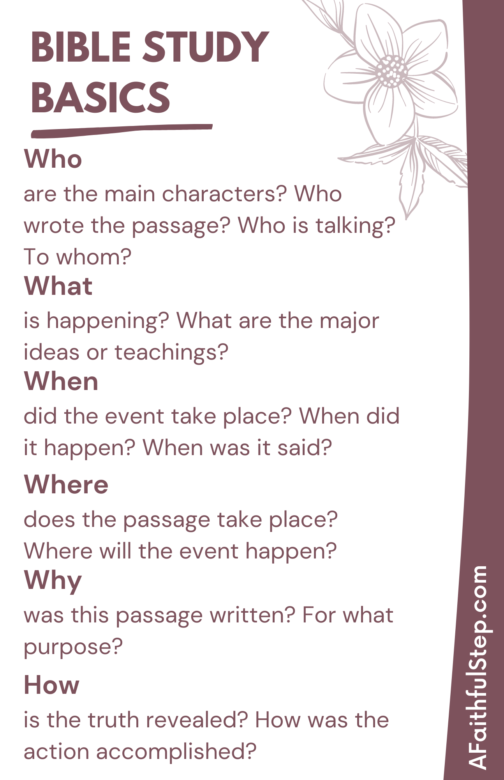
- Who: John the Baptist (title and verse 4), Jesus Christ, son of God (verse 1), Isaiah the prophet (verse 2), country of Judea and Jerusalem (verse 5)
- What: verse 2-3 refers to verses in Isaiah (OT) - a messenger will go and prepare the way for the Lord. All of Judea and Jerusalem were going to John the Baptist to be baptized (verse 4-5). John is preaching that someone is coming after him that is mightier (verse 7) and will baptize people with the Holy Spirit (verse 8).
- When: (not available in current reading)
- Where: River Jordan, in the wilderness (verse 5)
- Why: John is preparing the way for the Lord. (verse 7-8)
- How: John is baptizing people in water and preaching

Step 4: Apply What You Read (APPLICATION)
The application section is used to answer what this tells us about God? How should this change the way we are living? Sometimes, I use this area to paraphrase what I just read to help me understand it.
Every verse won’t necessarily have a specific application in your life, but it all points back to God, and knowing this should change the way we live.
In Isaiah, it was prophesied that a messenger would go before Jesus Christ to pave His way. That messenger was John the Baptist. John baptized people in water, but he also preached to folks telling them that someone better was coming along. God designed it so that John the Baptist would pave the way for Christ. John was obedient to God. He was humble. He allowed God to use him for a greater purpose than himself. Do I allow God to use me? Do I do so for my glory? Or for His?

Step 5: Close in Prayer (PRAYER)

Once you’ve accomplished writing your scripture, identifying your observations, and determining an application, you close in prayer. Pray over what you read. Pray for help with application or for wisdom to discern what you read. I typically write down my prayers, but you don’t have to.
Lord, your plan is far greater than I will understand. Even from the beginning, you had a plan to use people like John the Baptist, and I know you have a plan to use me. Help me to be obedient to your calling. Help me to be humble and to glorify you without seeking credit or applause. Lord, you know my weaknesses. You know where I struggle. I want to serve you without making it all about me. Amen.

Step 6: Repeat
The more you practice the S.O.A.P. method, the easier and more natural it will become. As I work my way through Mark, I will pick up where I left off, using a brand new sheet to pick a new verse and break it down.
Sometimes, I’ll read over my last reading and then continue reading until the next verse catches my eye. Some days, I will fill pages going through this method, and other days, I’ll barely fill a page.
It’s less about perfection and more about digging into the word and learning who God is.
Now that we’ve covered the basics check out this FREE resource “A Simple Bible Study Method: SOAP” exclusive for my email subscribers. It was designed to print out and help you through the S.O.A.P. Method.

